# SOFTWARE ENGINEERING ASSIGNMENT

## MODULE : 1

## SE – OVERVIEW OF IT INDUSTRY

### 1.What is software? What is software engineering?

Ans - Software is a set of instructions, data or programs used to operate computers and execute specific tasks.

Software engineering is the branch of computer science that deals with the design, development, testing, and maintenance of software applications. Software engineers apply engineering principles and knowledge of programming languages to build software solutions for end users.

### 2.Explain types of software

Ans - (1) Application Software

- The most common type of software, application software is a computer software package that performs a specific function for a user, or in some cases, for another application.

- An application can be self-contained, or it can be a group of programs that run the application for the user.

- Examples of Modern Applications include office suites, graphics software, databases and database management programs, web browsers, word processors, software development tools, image editors and communication platforms.

Example - Microsoft Office, Paint, Power- point etc.

(2) System Software:

-These software programs are designed to run a computer's application programs and hardware.

- System software coordinates the activities and functions of the hardware and software.

- It controls the operations of the computer hardware and provides an environment or platform for all the other types of software to work in.

- The OS is the best example of system software; it manages all the other computer programs.

- Other examples of system software include the firmware, computer language translators and system utilities.

Example : Notepad , Calculator etc.

(3) Driver Software :

- Also known as device drivers, this software is often considered a type of system software.

-Device drivers control the devices and peripherals connected to a computer, enabling them to perform their specific tasks.

-Every device that is connected to a computer needs at least one device driver to function.

-Examples include software that comes with any nonstandard hardware, including special game controllers, as well as the software that enables standard hardware, such as USB storage devices, keyboards, headphones and printers.

Example : Audio Driver, Video Driver etc.

(4) Middleware :

-The term middleware describes software that mediates between application and system software or between two different kinds of application software. For example, middleware enables Microsoft Windows to talk to Excel and Word.

-It is also used to send a remote work request from an application in a computer that has one kind of OS, to an application in a computer with a different OS. It also enables newer applications to work with legacy ones.

Example: database middleware, application server middleware.

(5) Programming Software :

-Computer programmers use programming software to write code. Programming software and programming tools enable developers to develop, write, test and debug other software programs.

-Examples of programming software include assemblers, compilers, debuggers and interpreters.

Examples : Turbo c, Eclipse ,Sublime etc.

### 3. What is SDLC? Explain each phase of SDLC ?

Ans - The Software Development Life Cycle (SDLC) refers to a methodology with clearly defined processes for creating high-quality software. in detail, the SDLC methodology focuses on the following phases of software development.

(1) Requirement Gathering :

It involves understanding the client's needs and identifying their problems. It also involves designing solutions. This phase is important to ensure that the final product is perfect.

(2 ) Analysis :

A requirement analysis that aims to determine the tasks that are needed to get fully functional software. This analysis undergoes various requirements of stakeholders, documenting, and validating software and system requirements.

(3) Designing :

This phase involves transforming the software requirements gathered during the Requirements Analysis phase into a structured design document.

(4) Implementation :

This phase is initiated after the system has been tested and accepted by the user. In this phase, the system is installed to support the intended business functions.

(5) Testing :

Once the developers build the software, then it is deployed in the testing environment. Then the testing team tests the functionality of the entire system. In this phase of SDLC, the testing is done to ensure that the entire application works according to the customer requirements.

(6) Maintenance :

The maintenance phase happens after the project team deploys the software and it's fully operational in the customer environment. During the maintenance phase, the customer monitors the software to ensure it continues to operate according to the coding specifications.

### 4. What is DFD? Create a DFD diagram on Flipkart?

Ans - A data flow diagram (DFD) maps out the flow of information for any process or system. It uses defined symbols like rectangles, circles and arrows, plus short text labels, to show data inputs, outputs, storage points and the routes between each destination.

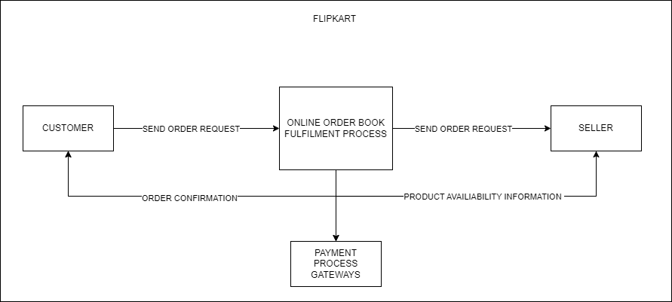

### 5. What is Flow chart? Create a flowchart to make addition of two numbers.

Ans - A programming flowchart is a visualization tool programmers use when creating new applications to understand a process, workflow or algorithm. It typically uses geometric shapes to represent steps and arrows to communicate the flow of data.

## Flowchart of making addition of two numbers:-

### 6. What is Use case Diagram? Create a use-case on bill payment on paytm.

Ans -Use-case diagrams describe the high-level functions and scope of a system. These diagrams also identify the interactions between the system and its actors. The use cases and actors in use-case diagrams describe what the system does and how the actors use it, but not how the system operates internally.

